Homework

1. Create your own **Vagrant** box based on **openSUSE**.

* SSH rule in port forwarding
* 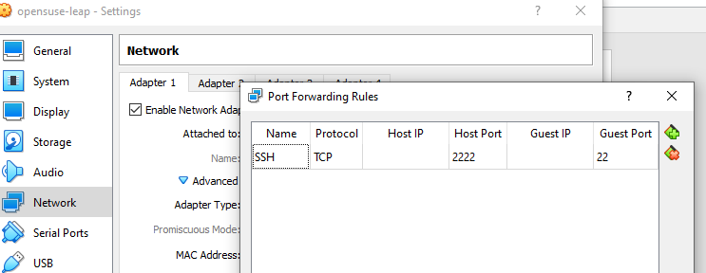

1. Upgrade all installed packages

**Sudo zypper update**

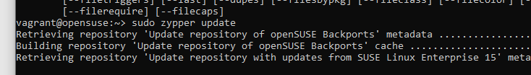

1. Mount the **VirtualBox** **Guest Additions**

**sudo mount /dev/sr0 /mnt**

**sudo /mnt/VBoxLinuxAdditions.run**

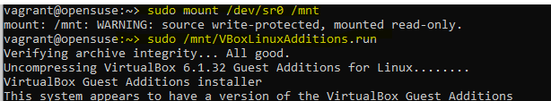

Add the **vagrant** user to the **vboxsf** group

**sudo usermod -aG vboxsf vagrant**

Set the **GRUB** waiting time to **0**

**sudo vi /etc/default/grub**

**sudo grub2-mkconfig -o /boot/grub2/grub.cfg**

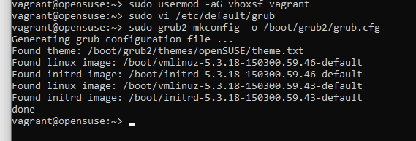

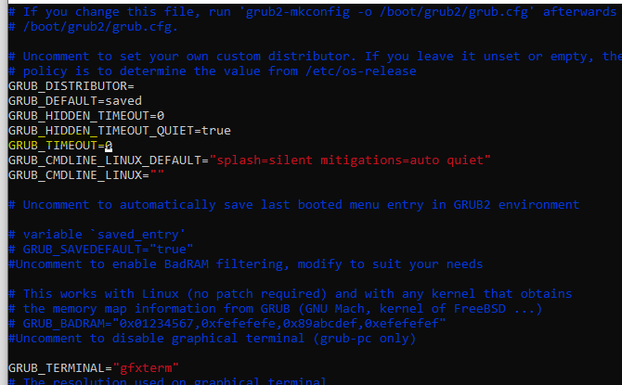

Add the **vagrant** user to the **sudoers** list and allow it to **sudo** without entering password

**echo "vagrant ALL=(ALL) NOPASSWD:ALL" | sudo tee /etc/sudoers.d/vagrant**

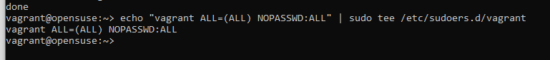

Install the **vagrant** insecure key

**mkdir -m 0700 -p /home/vagrant/.sshwget --no-check-certificate \**

**https://raw.github.com/mitchellh/vagrant/master/keys/vagrant.pub \**

**-O /home/vagrant/.ssh/authorized_keys**

**chmod 0600 /home/vagrant/.ssh/authorized_keys**

Clean up the **DNF** cache

* **sudo zypper clean**

Make sure that the hard disk is aligned:

**sudo dd if=/dev/zero of=/EMPTY bs=1M status=progress**

**sudo rm -f /EMPTY**

Reboot the **VM**

**sudo reboot**

1. While the **VM** is still running, build the box with

**vagrant package --base opensuse-leap**

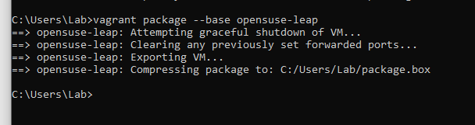

Add the box to the local catalog

**vagrant box add homework package.box**

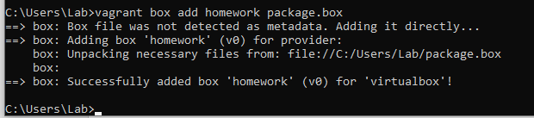

Create a configuration based on the local box

**vagrant init homework**

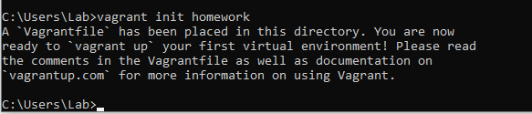

Power on the machine

**vagrant up**

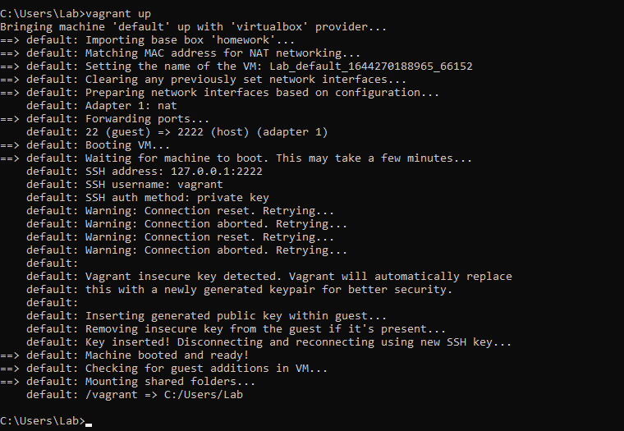

Connect to the machine

**vagrant ssh**

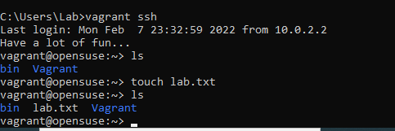

Turn off and delete the machine

**vagrant destroy --force**

